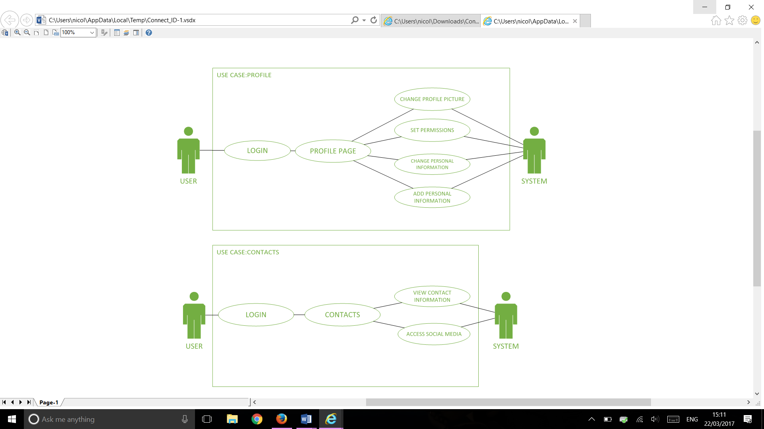

USE CASE 1

Primary Actor: Application user

Goal: change profile picture

Scope: connect ID application

Main Sequence:

1. The user logs into the application with their username and password
2. The system validates the username and password
3. The user selects their profile page
4. The user selects the edit profile button
5. The user selects the option to change their profile picture
6. The system asks which photo the use would like to select
7. The user selects the photo they wish to display
8. The system asks the user if the user is sure of this change
9. The user selects yes
10. The system changes the profile picture to the one selected

USE CASE 2

Primary Actor: Application user

Goal: set permissions

Scope: connect ID application

Main Sequence:

1. The user logs into the application with their username and password
2. The system validates the username and password
3. The user selects heir profile page
4. The user selects the setting option
5. The user can set their permissions such as who can see their profile
6. The system asks the user if the user is sure of this change
7. The user selects yes
8. The system sets the permissions

USE CASE 3

Primary Actor: Application user

Goal: change personal information

Scope: connect ID application

Main Sequence:

1. The user logs into the application
2. The system validates the username and password
3. The user selects their profile
4. The user selects the edit profile button
5. The user then changes the information on their profile by editing the text in the boxes
6. The system asks the user if they are sure of these changes
7. The user selects yes
8. The system makes the changes

USE CASE 4

Primary Actor: Application user

Goal: add personal information

Scope: connect ID application

Main Sequence:

1. The user logs into the application
2. The system validates the username and password
3. The user selects their profile
4. The user then selects the edit profile button
5. The user adds the information they wish into the given boxes
6. The system asks the user if they are sure of these changes
7. The user selects yes
8. The system adds the information to their personal profile

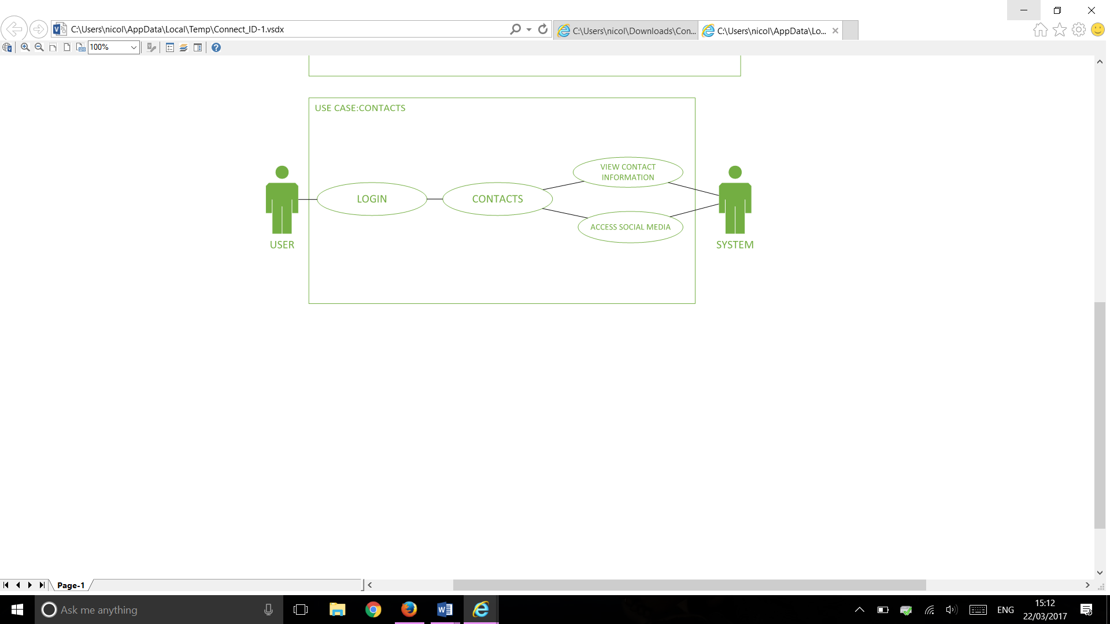

USE CASE 1

Primary Actor: Application user

Goal: view contacts

Scope: connect ID application

Main Sequence:

1. The use logs into the app using their username and password
2. The system validates the username and password
3. The user selects the contacts button
4. The user scrolls through the contacts on the page

USE CASE 2

Primary Actor: Application user

Goal: access social media

Scope: connect ID application

Main Sequence:

1. The use logs into the app using their username and password
2. The system validates the username and password
3. The user selects the contacts button
4. The user scrolls through the contacts on the page
5. The user selects the contact they are searching for
6. The system displays the contact
7. The user selects the social media displayed on the profile they wish to contact them on.